# CS 255 System Design Document Template

## UML Diagrams

## UML Use Case Diagram

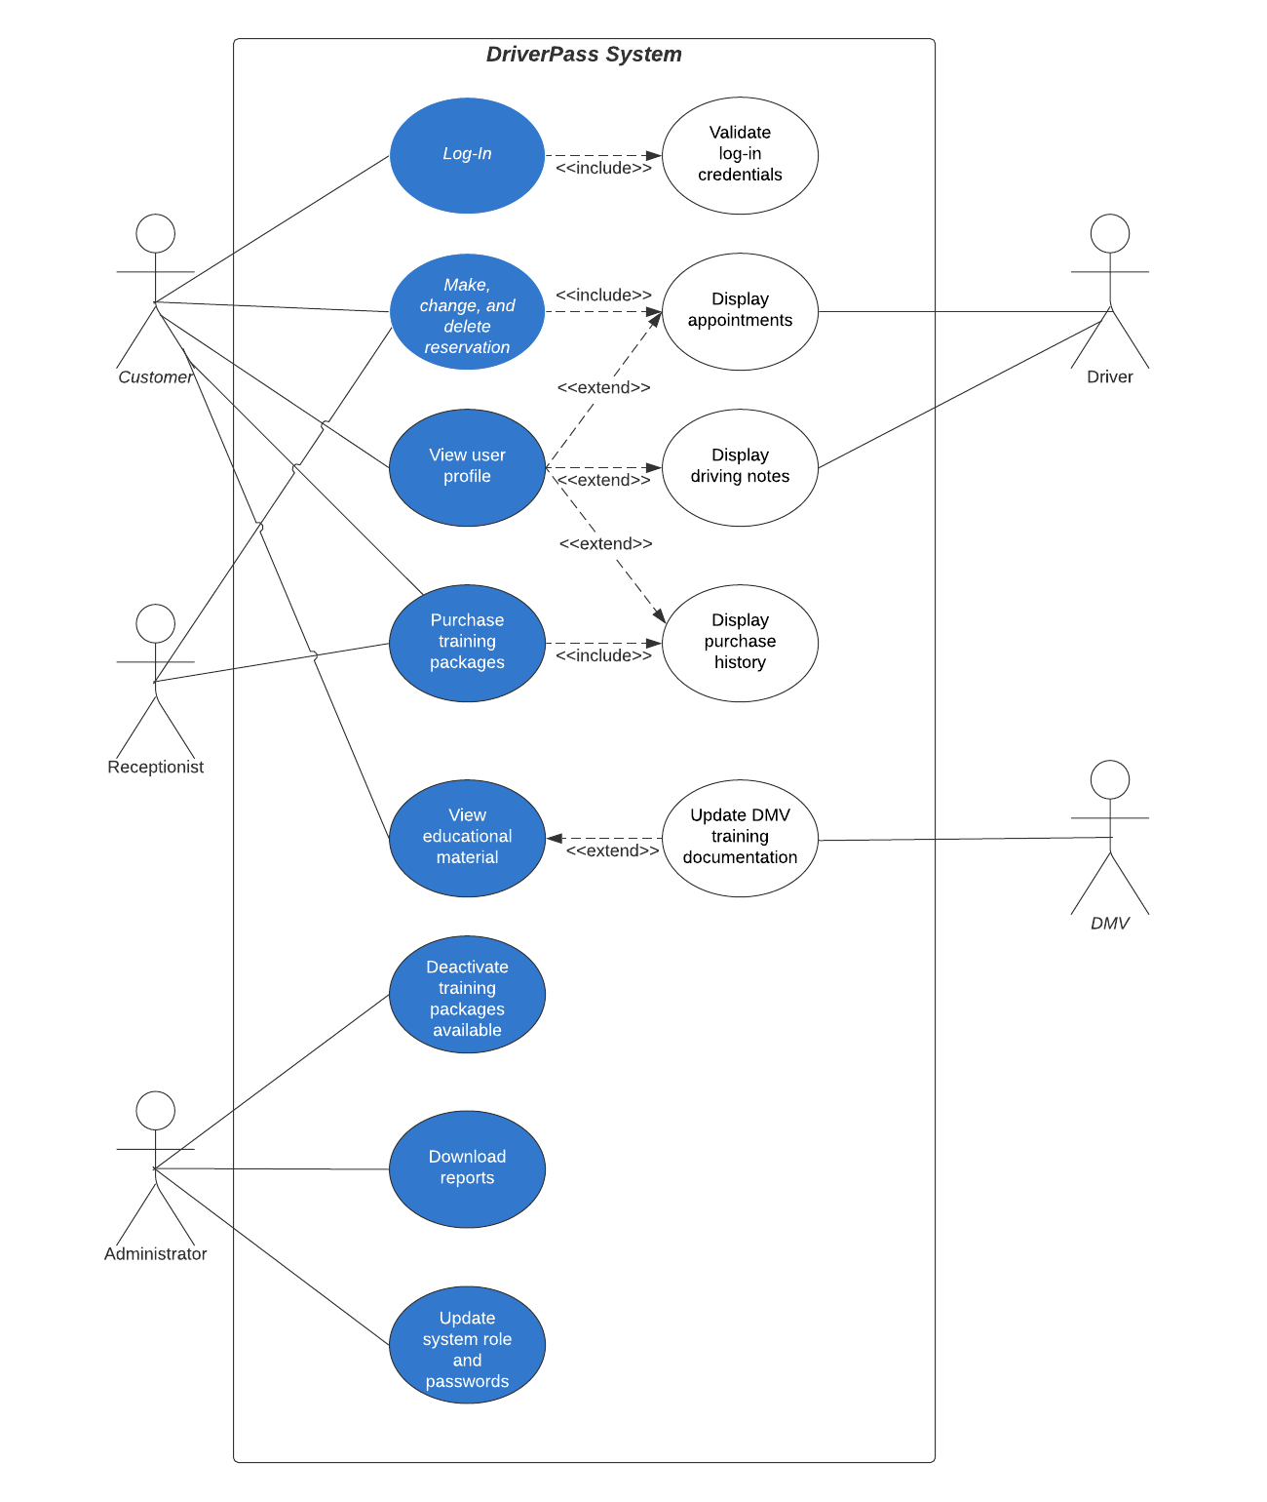

### UML Activity Diagrams

Login Activity Diagram

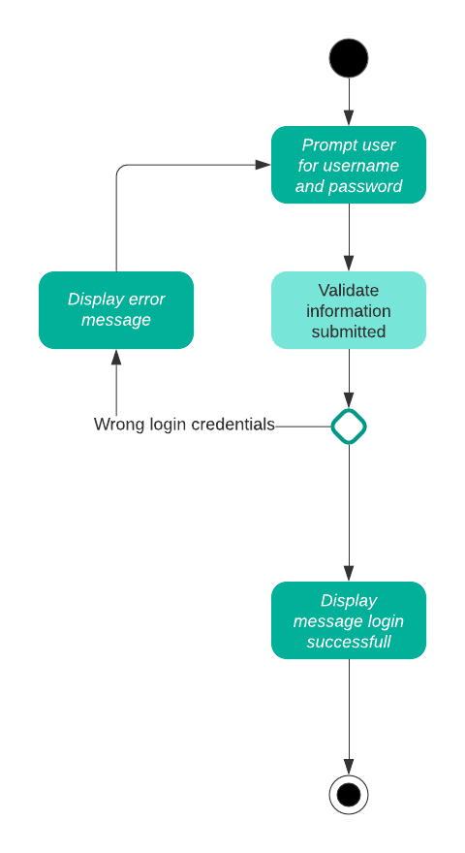

Reservation Activity Diagram

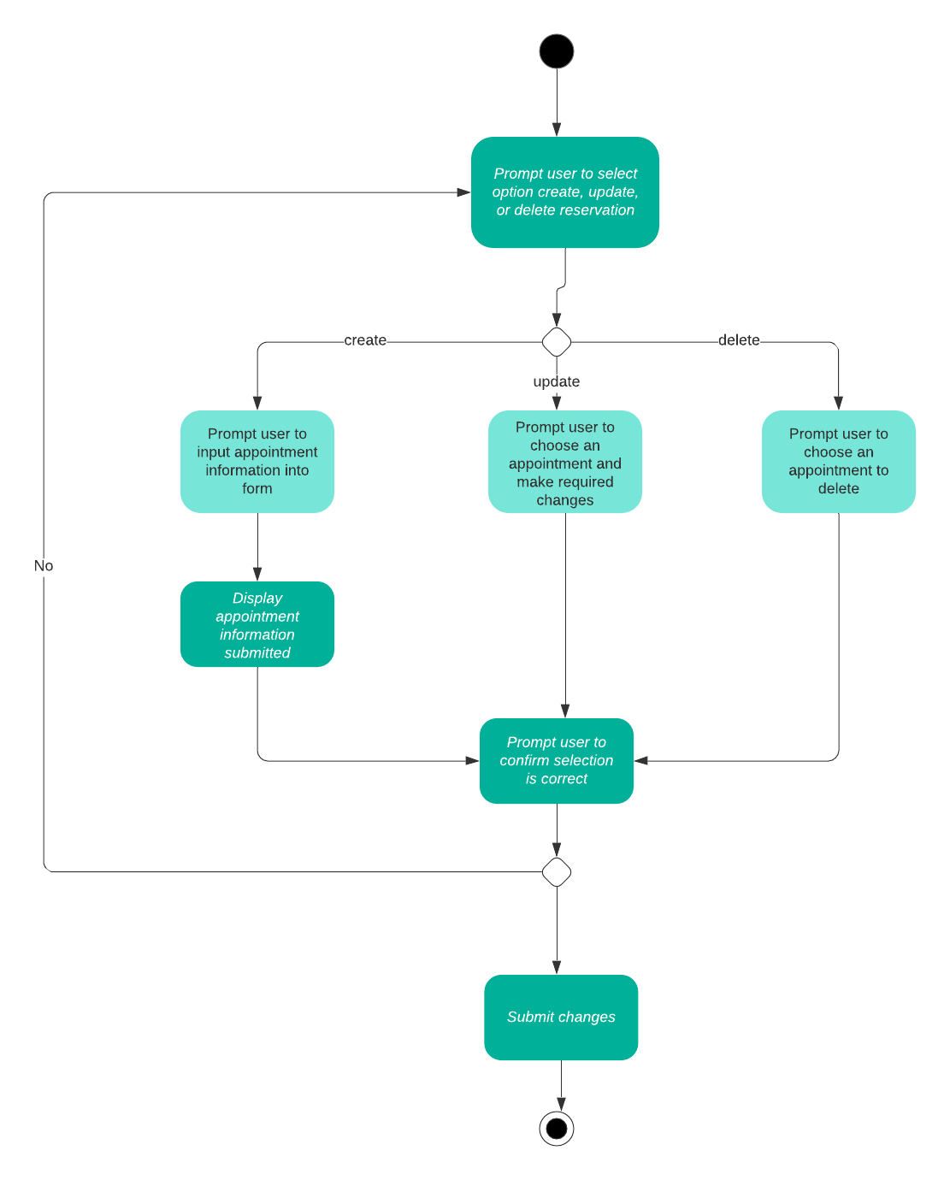

### UML Sequence Diagram

Login Sequence Diagrams

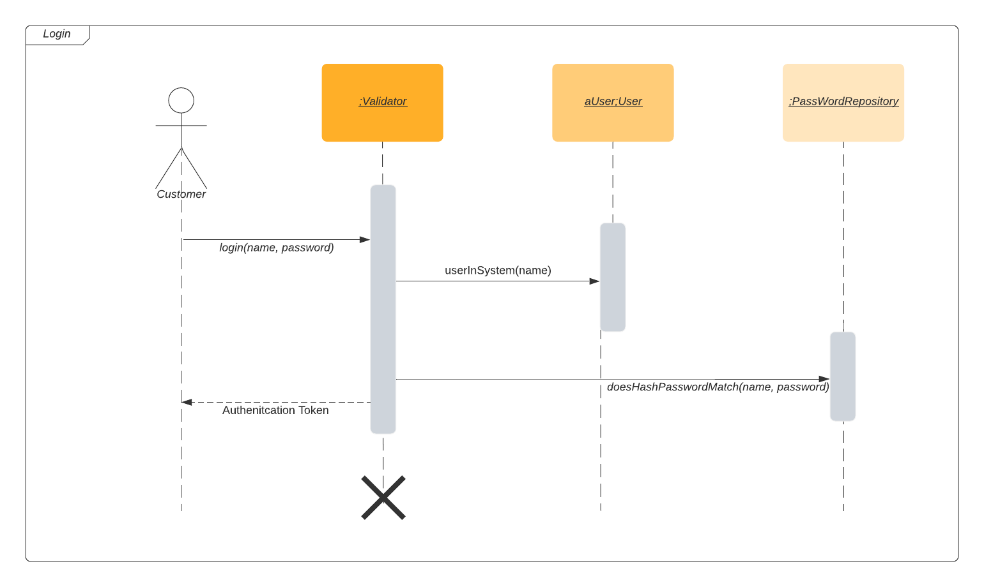

### UML Class Diagram

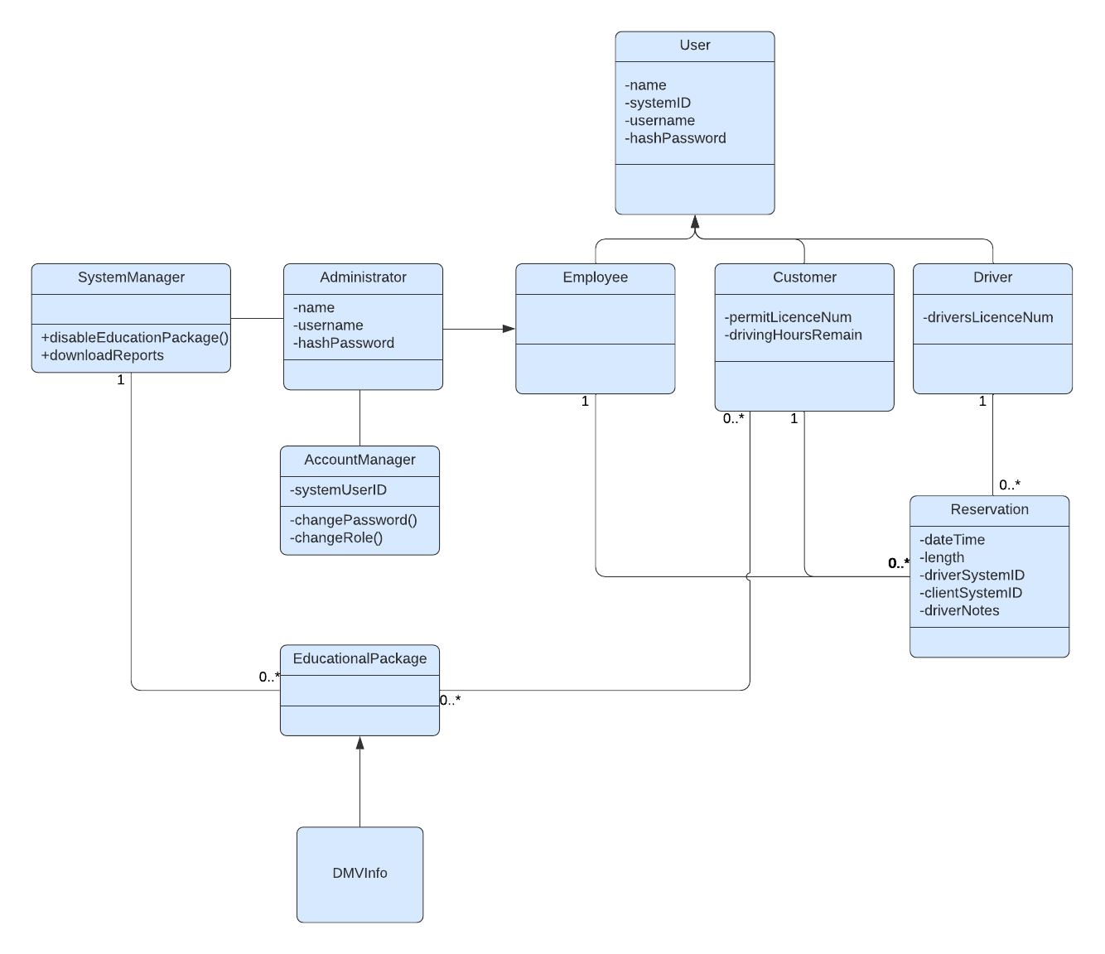

## Technical Requirements

* Hardware
  + Computer or mobile device
  + Internet accessible
* Software
  + Internet browser
* Geographic Information and Other
  + Located in a country DriverPass serves